Fall/Winter 2021 Writing Contest
To enter, fill out this form and send it (as an attachment is fine) to rlshoff@pencilprincessworkshop.com. Use “Spring 2021 Writing Contest” as the subject line.

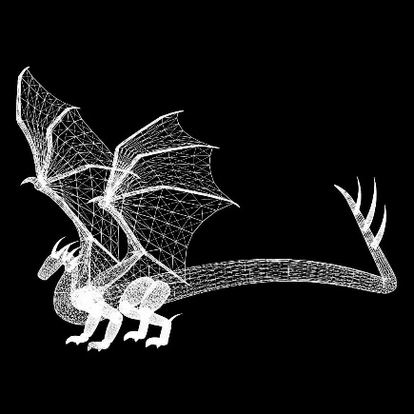
Name: _____________________________________
Title of Piece: ________________________________
___________________________________________
I affirm that I am the person named above, that this is my own original writing, and that I own all rights to it. I grant The Pencil Princess Workshop the non-exclusive right to publish it in the RLS Hoff Newsletter and on the pencilprincessworkshop.com website. I recognize that entering this contest does not obligate the Pencil Princess Workshop to publish this work, and that I retain all rights to this work. I am typing my name here as an official signature:______________
__________________________________________________________________
I am eighteen years old or older.
OR
I have obtained permission from my legal guardian, __________________________, to enter this contest. Good contact information for them is:
________________________________________________________
Submission: (copy and paste it below)

